Innovation & Commercialisation - Lancashire
Where we are now
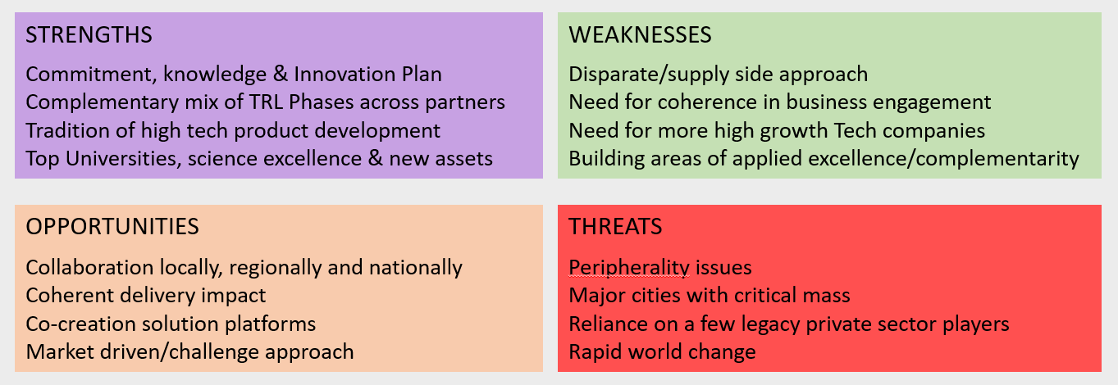

Lancashire has a formal Innovation Plan and has recently established an Innovation Board to unite key stakeholders and lead innovation actions. Through the LEP Strategic Framework, innovation is a cross cutting enabler and the county is developing a Local Industrial Strategy where innovation plays a key role in orchestrating growth.

- Lancashire has three Universities delivering research and innovation support programmes with increasing collaborative efforts. Lancashire has supported the establishment of a number of key Innovation assets across its geography (eg EIC, HIC, AMRC etc) with good partnership links and has skills support across five colleges. All Institutes have strong SME support with over 20 ESIF innovation programmes supporting thousands of SMEs.
- Lancashire has leading businesses with world-class expertise in R&D and manufacturing, notably in the aerospace, manufacturing and energy sectors and a history of product development with some key emerging market opportunities aligned to local strengths. Nevertheless it is somewhat reliant on a limited number of larger companies.
- In keeping with much of the North, Lancashire has lagged on SME R&D spend and business productivity and needs both more high growth innovative companies with international ambitions as well as adoption of new technologies in existing supply chains to keep ahead. The county needs to understand its future strengths and growth opportunities and how to cross-fertilise sectors, join up delivery and better fund innovation to broaden the economic base and improve impact.
- Lancashire has a polycentric geography requiring it to work at uniting its comparative advantages and finding synergies in the face of more compact metropolitan centres more easily able to achieve critical mass. The county needs to better understand the depth and breadth of its strengths and their complementarity with partners locally and nationally in order to lead on building cluster critical mass that advantages Lancashire and reaches out across the Northern region and to the world.
Where we want to be
KPIs
- Capture of Govt funds for Innovation (eg ESIF shift to SPF)
- Scale of collaborative support projects (county/region)
- Business attendance/membership in cross sector activities
- Rate of start-up/scale-up innovative companies in key sectors
- Increase in number/size of UKRI projects secured
- Increase in SME R&D spend towards 2.4% target
- Increase in risk capital attracted to innovative SME projects
- Number of case studies cited locally, regionally & internationally
Lancashire will collaborate further across stakeholders to develop specific, joined-up and impactful actions that add value to our assets and leads to a culture of innovation that lifts existing businesses and generates high growth businesses of the future, while reinforcing its successful role and interaction in the wider world. Key outcomes in 5 years will include:

- Lancashire will have developed its specialisations and accelerated more businesses in key growth areas
- Lancashire will have joined up key assets into networks better able to achieve critical mass of delivery
- Lancashire will have cross fertilised sectors and small and large companies to realise new opportunities
- Lancashire will have raised the productivity & technology of established sectors/supply chains to stay ahead
- Lancashire will have built wider national and international reach to be world class and communicate its success

How will we get there
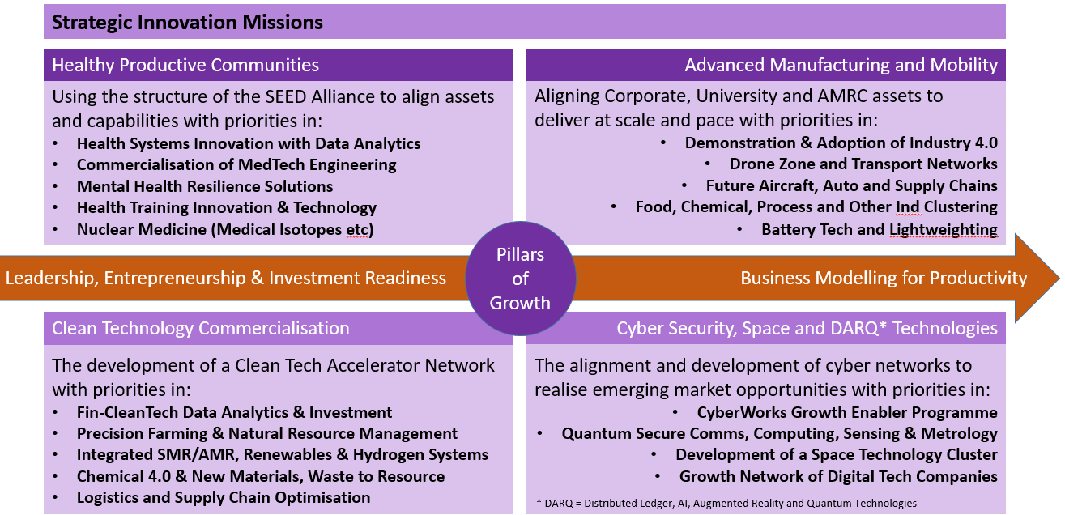

Lancashire will build on its strengths and achieve its targeted outcomes through its on-going mapping and analysis, which has identified where its deep strengths coincide with growth opportunities. The diagram to the right shows this as enabling innovation missions that cross cut the Pillars of Growth.

These Missions represent areas requiring intervention, platforms for “Asks” to Government and bidding pipelines. The Innovation Delivery Plan will orchestrate around these Strategic Innovation Missions and provide structure and direction to join-up assets as follows:

- The consolidation and further development of the Innovation Board
- The development of an Innovation Observatory/Brokerage, a Marketing Strategy and Innovation Champions
- The focusing of impact through resourcing four networks to advance the Strategic Innovation Missions
- The use of best practice tools and approaches across intervention partners and the streamlining of structures to achieve coherence of delivery and impact.
- The key role of Leadership, Entrepreneurship, Investment Readiness & Productivity programmes to ensure absorptive capacity for any innovation and technology commercialisation across the Missions and Growth Pillars.

